
ASSIGNMENT COVER SHEET
Student’s Details
Student’s FULL Name |  |  | Student ID
FIRST Name |  | FAMILY Name | Student ID
Shreejal |  | Rai | 21136889
Unit Code | ISYS3014
Unit Title | Business Analytics Techniques
Name of Assignment | Assignment 03: Business Analytics Project
Due Date | Friday 23rd May, 2025 (1700 AWST)

Student declaration:
- This assignment is my own original work, except where I have appropriately cited the original source.
- Where I have used Gen-AI, I have included a statement about the nature and extent of its use and a copy of the text generated by the Gen-AI tool.
- This assignment has not previously been submitted in any form for this or any other unit, degree or diploma at any university or other institute of tertiary education.
- I acknowledge that it is my responsibility to check that the file I have submitted is:
  - a) readable,
  - b) the correct file, and
  - c) fully complete.

Contents
Executive summary 3
Introduction 3
Report Findings 4
Changes in Norway’s Renewable Electricity Share Since 2005 4
Norway’s Renewable Energy Mix Over Time 5
Norway vs Neighbours: Renewable Generation 6
Norway’s Renewable Generation Forecast 7
Conclusion 8
Appendices 9
Data Sources 9
ETL Process (Extract, Transform and Load) 9
Extract 9
Transform 9
Load 9
Power BI Report structure 9
Assumptions and Limitations 10
DAX Formulas 10
References 12

Executive summary
This report investigates the state and trajectory of renewable electricity generation in Norway, with a focus on how the country’s energy profile has evolved since 2005, how it compares to neighbouring Nordic nations, and what projections suggest for 2030. The analysis is structured around four guiding questions covering renewable share, energy mix composition, regional comparison, and future outlook.
To answer these questions, data was sourced from Our World in Data and transformed in Power BI. Key steps included filtering for relevant countries, restructuring the dataset through unpivoting, and calculating new DAX measures to analyse electricity generation trends. A series of four interactive visuals were developed to communicate findings clearly and intuitively, with design choices guided by best practices in data visualisation and dashboard usability.
Findings reveal that Norway consistently generates more than 90% of its electricity from renewable sources, with hydropower as the dominant contributor. Since 2015, wind energy has also begun to play a larger role. Compared to Sweden, Denmark, and Finland, Norway leads in absolute renewable output—a trend largely supported by its long-standing hydropower infrastructure. The forecast model projects continued stability, estimating around 145 TWh of renewable generation by 2030, although uncertainty remains due to environmental and policy factors.
The report concludes that Norway holds a strong and consistent position in renewable electricity generation. However, it also acknowledges that further work could explore factors beyond generation—such as energy consumption, grid capacity, and policy impacts—to provide a fuller picture of energy sustainability in the region.

Introduction
As countries transition toward cleaner energy systems, understanding how electricity is generated and where progress is being made has become increasingly important. This report examines the state of renewable electricity generation in Norway through a data-driven lens, exploring historical trends, changes in energy composition, regional comparisons, and future forecasts. Norway is the primary focus of this analysis, with Denmark, Sweden, and Finland providing regional context to assess the growth and diversification of renewable energy sources.
Norway was selected as the primary country due to its long-standing track record in renewable energy generation. This not only provided a variety of data to work with but also made it easier to curate accurate, consistent information across the time span dating from the year 2005. For comparing Norway’s performance, three neighbouring countries – Denmark, Sweden and Finland were chosen. These countries were not only geographically and policy-aligned but also represent a form of regional competition in renewable energy progress, creating an interesting benchmark dynamic. For instance, the Nordic Statistics Database reports that as of 2023, all five Nordic countries met the EU's 2030 renewable energy target of 42.5% ahead of schedule, with Sweden, Finland, and Denmark achieving the highest shares among EU countries, and Norway and Iceland surpassing even these figures. (Nordic Statistics 2024)
The dashboard was designed with accessibility and clarity in mind. A key objective was to ensure that users regardless of their prior experience with renewable energy or data visualisations—could interpret the findings within 30 seconds or less. This informed the layout, chart types, colour choices, and interactivity. Each visual aims to immediately convey key insights without requiring additional explanation.
Ultimately, the purpose of this report is to deliver direct, understandable insights to the client, offering a clear view of Norway’s renewable electricity generation patterns, its energy mix, and how it compares regionally both now and into the future.

Report Findings

Changes in Norway’s Renewable Electricity Share Since 2005

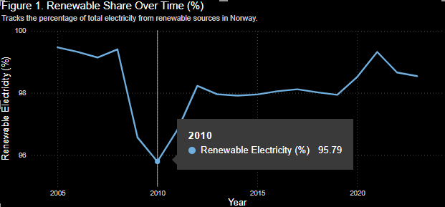Figure 1. Renewable Share of Electricity in Norway
Understanding how the proportion of electricity generated from renewable sources has changed over time provides key insight into a country’s long-term commitment to sustainability and low-emission energy production. In this section, the focus is placed on Norway’s renewable electricity share between 2005 and 2023, with attention to both overall stability and any meaningful shifts in generation patterns.
The analysis uses historical electricity generation data from Our World in Data, filtered to include only Norway. Data transformations were carried out in Power BI to calculate yearly renewable shares as a percentage of total electricity generation. A line chart visualisation was used to present these findings (Figure 1). The chart uses a line graph to track the renewable share year-by-year.
This visual format was chosen based on data visualisation principles that recommend line charts for tracking trends over time. It enables viewers to easily identify periods of stability and fluctuation in the renewable share across the nearly two-decade span.
The visualisation shows that Norway has consistently generated over 90% of its electricity from renewable sources throughout 2005-2023. The renewable share remained high even as the total electricity generation varied from year to year, highlighting Norway’s consistent dependence on clean energy sources. Hydropower remains the dominant source throughout the period, while wind energy begins to register meaningful growth after 2015. Notably, this increase in wind generation did not displace hydro, but rather contributed to a slight diversification of Norway’s renewable portfolio.
In 2010, Norway’s renewable electricity share dropped to 95.79%, the lowest point in the observed period. This decline was not due to a significant increase in non-renewable generation but was primarily caused by a reduction in hydropower output. The decrease in hydroelectric production was attributed to lower water inflows, a consequence of reduced precipitation levels during that year, which are critical for Norway's hydro-dependent electricity system (Nordisk Energiforskning 2010, 10).

Norway’s Renewable Energy Mix Over Time

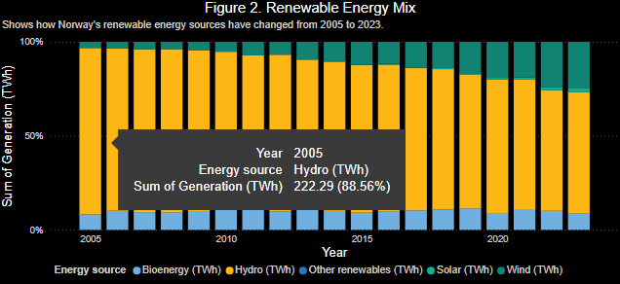Figure 2. Composition of Norway’s Renewable Electricity Mix (2005–2023)
This section examines how the composition of Norway’s renewable electricity generation has changed from 2005 to 2023. While hydropower has long been the backbone of the country's clean energy supply, this analysis explores whether other renewable sources have gained a stronger foothold over time.
The data was sourced from Our World in Data and filtered to show only Norway’s renewable electricity generation. A 100% stacked column chart was used to visualise the changing contributions of hydropower, wind, solar, bioenergy, and other renewables. This chart type was selected because it allows the viewer to focus on the proportional relationship between sources, regardless of total generation volume. A line chart or raw column chart would not have highlighted the internal balance between energy types as effectively.
The visualisation shows that hydropower has consistently remained as Norway’s dominant renewable electricity mix. However, wind energy begins to show meaningful growth from 2015 onward, with a noticeable jump around 2018–2020. This increase suggests steady investment in wind infrastructure. Notably, between 2017 and 2020, Norway experienced a significant wind power installation boom, with the number of wind turbines reaching 800 across 42 wind power plants by April 2020 (Skjærseth et al. 2023, 85). Interactive tooltips in the Power BI visual enable users to examine the percentage contributions of each source by year, offering a more detailed exploration of the trend.
The diversification seen in recent years, particularly the growth in wind energy, suggests that Norway is beginning to build out its renewable portfolio beyond hydropower. However, the momentum of diversification remains moderate, and hydro remains structurally essential to the country's electricity system.
Norway’s renewable electricity mix has changed gradually since 2005. While hydropower remains the dominant source, wind energy has begun to emerge as a secondary contributor, adding some diversity to an otherwise hydro-heavy energy profile.

Norway vs Neighbours: Renewable Generation

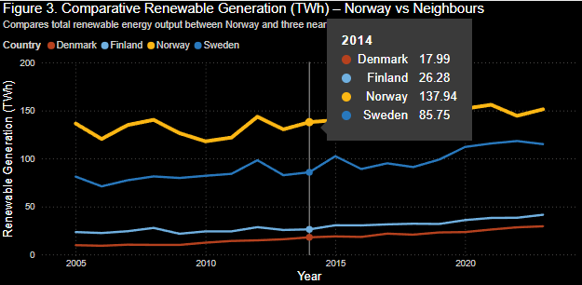
Figure 3 Comparative Renewable Electricity Generation (TWh)
This section compares Norway’s renewable electricity generation with that of its Nordic neighbours Denmark, Sweden, and Finland between 2005 and 2023. This comparison helps evaluate whether Norway’s energy transition progress is exceptional or in line with regional developments. A line chart was used to visualise trends over time, as line charts are particularly effective for comparing the time series data across multiple groups. Norway remains the focus, highlighted with a more defining line colour and is consistently positioned highest throughout the period.
The data was again sourced from Our World in Data and filtered in Power BI to isolate total renewable electricity generation per country per year. The tooltip interactivity enhances user understanding by allowing year-by-year inspection of energy generation values, providing a better context beyond what is visible in the line chart alone. A bar or stacked chart was avoided, as it would not effectively show time-based patterns or allow easy comparison of changes between countries.
For example, in 2021, Norway peaked at approximately 156 TWh, significantly ahead of Sweden’s 115 TWh and Finland’s 40 TWh. Denmark, while starting lower at around 10 TWh in 2005, showed consistent progress, reaching nearly 30 TWh by 2023. This growth reflects its strategic emphasis on wind energy, which made up 43% of its electricity consumption as early as 2016 (RTE News 2018). Sweden’s renewable electricity generation, which grew from around 80 TWh in 2005 to over 115 TWh by 2022, is largely driven by its combination of hydropower and bioenergy sources (Nordic Energy Research 2015).
Although other countries have made substantial progress, particularly Sweden and Finland, none have yet surpassed Norway in absolute generation. This sustained lead underscores Norway’s early and ongoing investment in renewable infrastructure, particularly hydropower, which accounted for 92% of its electricity generation in 2020 (IEA 2022).

Norway’s Renewable Generation Forecast

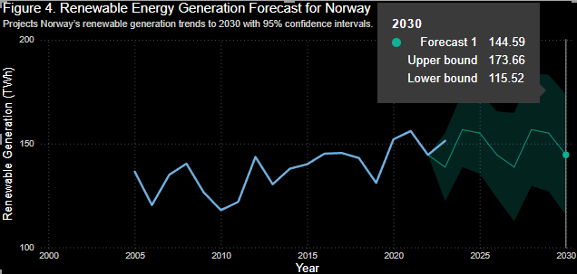
Figure 4. Renewable Energy Generation Forecast (TWh)
This section presents a forecast of Norway’s renewable electricity generation through to 2030. Forecasting trends in clean energy production is crucial for energy planning, sustainability strategy, and tracking national alignment with long-term climate goals. The analysis aims to estimate the projected output of renewable electricity under current trajectory conditions.
The forecast was generated using Power BI’s built-in forecasting tool applied to a historical line chart visual. The underlying data includes Norway’s annual renewable electricity generation (in terawatt-hours) from 2005 to 2023, sourced from Our World in Data. The forecast function uses this historical trend to project future values, beginning in 2024, and includes a 95% confidence interval represented by the shaded area surrounding the forecast line.
The visualisation shows that Norway’s renewable electricity generation is expected to remain relatively stable over the next several years, with a predicted value of approximately 144.6 TWh by 2030. The upper and lower bounds of the 95% confidence interval suggest a reasonable range between 115.5 TWh and 173.7 TWh, indicating uncertainty in future energy production depending on environmental, economic, or policy factors.
Despite fluctuations in past output, the overall course suggests Norway’s continued reliance on renewable sources at a high level. This forecast aligns with the historical use of hydropower and recent investments into wind energy, which are expected to retain Norway’s position as a leader in renewable electricity generation.
The interactive elements in the Power BI chart allow users to hover over each year to examine forecasted values and confidence bounds, making the projection both transparent and engaging.

Conclusion
This report set out to explore how Norway generates its renewable electricity, both on its own and in comparison to neighbouring countries. Using data from Our World in Data and building interactive visuals in Power BI, I worked through four core questions focused on Norway’s renewable share, the mix of sources, how it stacks up regionally, and where things might be heading by 2030.
The analysis confirmed that Norway has consistently generated more than 90% of its electricity from renewable sources since 2005 one of the highest rates globally. Hydropower continues to dominate, but wind energy has started to grow steadily since 2015. When compared with Denmark, Sweden, and Finland, Norway leads in total renewable output, thanks to its long-standing investments in hydropower and natural advantages in geography. Based on the forecast model, that lead is expected to hold steady through 2030, with output hovering around 145 TWh, though there's some uncertainty built into the prediction.
Power BI played a key role throughout the project, not just for filtering and transforming the data, but for helping shape clear, accessible visualisations. Features like tooltips and forecast confidence ranges made it easier to explore the results without overloading the viewer.
Of course, there are a few gaps. The forecast is based only on past data, so it doesn’t reflect future policy changes or unpredictable events. Also, the report focused purely on electricity generation, so topics like storage, or demand weren’t explored.
Overall, the project shows how strong Norway’s position is when it comes to renewable electricity, while also pointing out how its mix is slowly shifting. It also highlights the value of comparing across countries and using forecasting tools to help inform future energy decisions.

Appendices

Data Sources
The project used two main datasets from Our World in Data:
Energy Source Change (Annual)
Contains yearly renewable electricity generation by source and country (in TWh)
Yearly Electricity Generation (Long Format)
Used to calculate total generation and apply forecasting for Norway
Both datasets were downloaded as .xlsx files and imported into Power BI.

ETL Process (Extract, Transform and Load)

Extract
Downloaded Excel files from OWID’s public data portal

Transform
Filtered for: Norway, Sweden, Denmark, Finland
Unpivoted source columns to long format (Energy Type, Value)
Renamed columns for clarity (e.g., "Electricity from hydro (TWh) to "Hydro")
Created DAX measures to calculate renewable totals, shares, and individual source values

Load
Loaded cleaned tables into Power BI
Created relationships between Country and Year fields across tables

Power BI Report structure
Figure | Question | Chart | Notes
1 | Renewable energy share in Norway. | Line + Stacked Column | Dual axis for share and total breakdown
2 | Breakdown of renewable sources over time. | 100% Stacked Column | Shows relative source mix per year
3 |  | Line Chart | Compares Norway to Denmark, Sweden and Finland
  Country comparison of renewable output.
4 | Forecast to 2030 | Line Chart with Forecast | Built-in Power BI forecast + confidence interval

Each chart includes:
- Interactive tooltips for detailed values.
- Slicers or filters (where needed).
- Norway is visually highlighted in comparative visuals.

Assumptions and Limitations
- Forecast does not account for future policies, market changes, or climate impacts
- The project focuses only on generation, not consumption, grid design, or storage

DAX Formulas
Non-renewable Generation (TWh)
Non-Renewables (TWh) = [Total Generation (TWh)] - [Total Renewables (TWh)]
Total Renewable Generation (TWh)
Renewable Generation (TWh) =
SUM('Electricity_Generation_Clean'[Hydro (TWh)]) +
SUM('Electricity_Generation_Clean'[Wind (TWh)]) +
SUM('Electricity_Generation_Clean'[Solar (TWh)]) +
SUM('Electricity_Generation_Clean'[Bioenergy (TWh)]) +
SUM('Electricity_Generation_Clean'[Other Renewables (TWh)])
Renewable Share of Electricity (%) =
DIVIDE(
[Total Renewables (TWh)],
[Total Generation (TWh)],
0
) * 100
Total Electricity Generation (TWh)
Total Generation (TWh) =
SUMX(
'Electricity_Generation_Clean',
[Coal (TWh)] +
[Gas (TWh)] +
[Hydro (TWh)] +
[Solar (TWh)] +
[Oil (TWh)] +
[Wind (TWh)] +
[Bioenergy (TWh)] +
[Other Renewables (TWh)]
)
Total Renewable Generation (TWh)
Total Renewables (TWh) =
SUM('Electricity_Generation_Clean'[Hydro (TWh)]) +
SUM('Electricity_Generation_Clean'[Wind (TWh)]) +
SUM('Electricity_Generation_Clean'[Solar (TWh)]) +
SUM('Electricity_Generation_Clean'[Bioenergy (TWh)]) +
SUM('Electricity_Generation_Clean'[Other Renewables (TWh)])

References
Nordic Statistics. 2024. “The 5 Large Nordic Countries All Met the EU’s 2030 Renewable Energy Target in 2023”. Accessed May 18, 2025. https://www.nordicstatistics.org/news/the-5-large-nordic-countries-all-met-the-eus-2030-renewable-energy-target-in-2023/
Nordisk Energiforskning. 2010. “Nordic Electricity Supply and Demand in a Changing Climate.” Accessed May 19, 2025. https://www.ea-energianalyse.dk/wp-content/uploads/2020/02/706_nordic_electricity_supply_and_demand_in_changing_climate.pdf.
Skjærseth, Jon Birger, Teis Hansen, Jakob Donner-Amnell, Jens Hanson, Tor Håkon Jackson Inderberg, Helle Ørsted Nielsen, Birgitte Nygaard, and Markus Steen. 2023. “Norway.” In Wind Power Policies and Diffusion in the Nordic Countries, 79–101. Cham: Springer. https://doi.org/10.1007/978-3-031-34186-1_5
International Energy Agency. 2022. Norway 2022: Energy Policy Review. Accessed May 23, 2025. https://www.iea.org/reports/norway-2022
Nordic Energy Research. 2015. “Renewables and Nuclear – Sweden.” Accessed May 23, 2025. https://www.nordicenergy.org/figure/a-third-renewable-half-co2-free-but-oil-still-the-largest-energy-source/renewables-and-nuclear/
RTE News. 2018. “Denmark on Track to Have 50% Renewable Energy by 2030.” Accessed May 23, 2025. https://www.rte.ie/news/newslens/2018/0111/932573-denmark-wind-farm/

